**A PROJECT REPORT ON**

**AIR CANVAS APPLICATION**

**USING OPENCV AND PYTHON3**

***Mini project submitted in partial fulfilment of the requirements for the***

***award of the degree of***

**BACHELOR OF TECHNOLOGY**

**IN**

**INFORMATION TECHNOLOGY**

**(2020-2024)**

**BY**

**Y. AMBIKA 20241A12H9**

**C.AVANTHIKA 20241A12C7**

**B. PUSHPANKA 20241A12C4**

***Under the Esteemed guidance***

***of***

**Dr.R.V.S.S.S.Nagini**

**Associate Professor**

**Dept of IT.**



**DEPARTMENT OF INFORMATION TECHNOLOGY**

**GOKARAJU RANGARAJU INSTITUTE OF ENGINEERING AND TECHNOLOGY**

**(AUTONOMOUS)** **HYDERABAD**



***CERTIFICATE***

This is to certify that it is a bonafide record of Mini Project work entitled **“AIR CANVAS APPLICATION USING OPENCV AND PYTHON3”** done by **Y.AMBIKA(20241A12H9),C.AVANTHIKA(20241A12C7),B.PUSHPANKA(20241A12C4),** of **B.Tech (IT)** in the Department of Information Technology, **Gokaraju Rangaraju Institute of Engineering and Technology** during the period 2020-2024 in the partial fulfilment of the requirements for the award of degree of **BACHELOR OF TECHNOLOGY IN INFORMATION TECHNOLOGY** from GRIET, Hyderabad.

**Dr.R.V.S.S.S.Nagini, Dr.N.V.Ganapathi Raju ,**

**Associate professor. Head of the Department.**

**(Internal project guide)**

**(Project External)**

**ACKNOWLEDGEMENT**

We take immense pleasure in expressing gratitude to our Internal guide**, Dr.R.V.S.S.S.Nagini,** Associate Professor, Dept. of IT, GRIET. We express our sincere thanks for her encouragement, suggestions and support, which provided the impetus and paved the way for the successful completion of the project work.

We wish to express our gratitude to **Dr. N. V. Ganapathi Raju,** HOD IT **,** our Project Co-ordinators**, P.K Abhilash** and **B. Kanaka Durga** for their constant support during the project.

We express our sincere thanks to **Dr. Jandhyala N Murthy,** Director, GRIET**,** and **Dr. J. Praveen,** Principal, GRIET**,** for providing us the conductive environment for carrying through our academic schedules and project with ease.

We also take this opportunity to convey our sincere thanks to the teaching and non-teaching staff of GRIET College, Hyderabad.

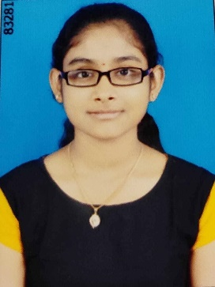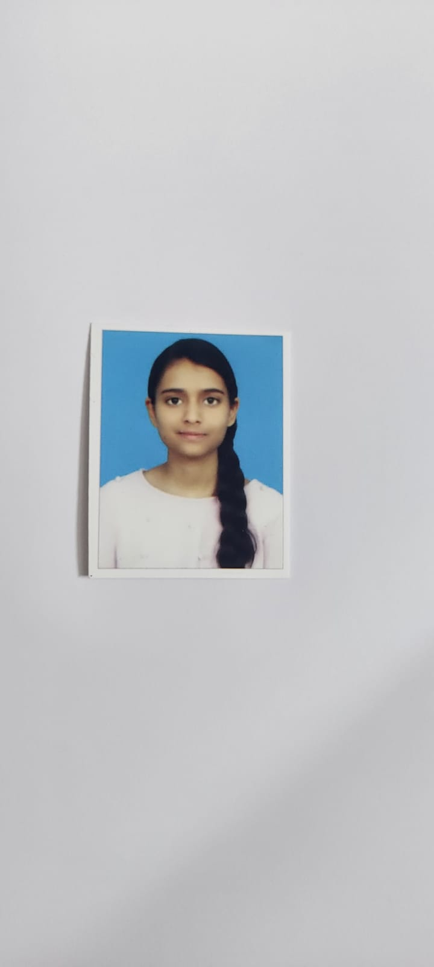

Name: Y. Ambika Name: C. Avanthika

Email: [ambikayamadri@gmail.com](mailto:ambikayamadri@gmail.com) Email: avanthikasrivatsa@gmail.com

Contact No.:9849576210 Contact No.: 93980 83775

Address: Nizampet, Hyderabad. Address: Nizampet,Hyderabad.

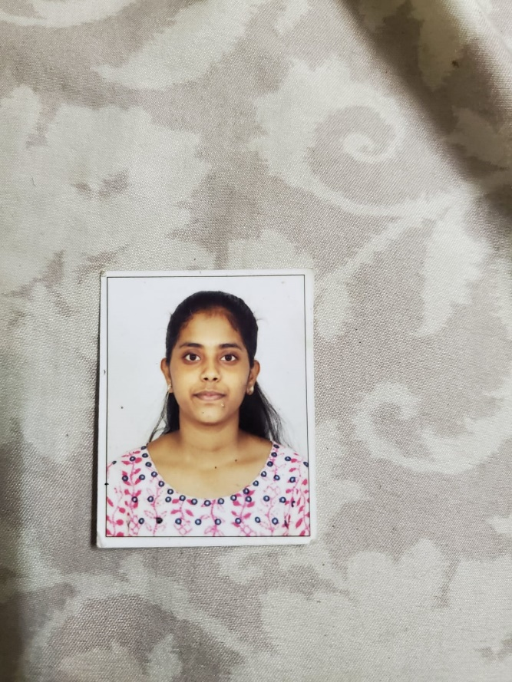

Name: B. Pushpanka

Email: Pushpanka.bhogadi21@gmail.com

Contact No.: 79952 19524

Address: Bachupally, Hyderabad.

**DECLARATION**

This is to certify that the project entitled “**AIR CANVAS APPLICATION USING OPENCV AND PYTHON3”** is a bonafide work done by us in partial fulfilment of the requirements for the award of the degree **BACHELOR OF TECHNOLOGY IN INFORMATION TECHNOLOGY** from Gokaraju Rangaraju Institute of Engineering and Technology, Hyderabad.

We also declare that this project is a result of our own effort and has not been copied or imitated from any source. Citations from any websites, books and paper publications are mentioned in the Bibliography.

This work was not submitted earlier at any other University or Institute for the award of any degree.

**Y. AMBIKA 20241A12H9**

**C.AVANTHIKA 20241A12C7**

**B. PUSHPANKA 20241A12C4**

**TABLE OF CONTENTS**

|  |  |  |
| --- | --- | --- |
| **Serial no** | **Name** | **Page no** |
|  | **Certificates** | 2 |
|  | **Contents** | 5 |
|  | **Abstract** | 7 |
| **1** | **INTRODUCTION** | 8 |
| 1.1 | Introduction to project | 8 |
| 1.2 | Existing System | 9 |
| 1.3 | Proposed System | 11 |
| **2** | **REQUIREMENT ENGINEERING** | 12 |
| 2.1 | Hardware Requirements | 12 |
| 2.2  2.3 | Software Requirements  Functional Requirements | 12  12 |
| **3** | **LITERATURE SURVEY** | 14 |
| **4** | **TECHNOLOGY** | 16 |
| **5** | **DESIGN REQUIREMENT ENGINEERING** | 28 |
| 5.1  5.2  5.3  5.4  5.5 | Activity Diagram  Use Case Diagram  Sequence Diagram  Dataflow Diagram  Architecture Diagram | 28  29  32  33  34 |
| **6** | **IMPLEMENTATION** | 36 |
| 6.1 | Modules | 36 |
| 6.2 | Sample Code | 37 |
| **7** | **SOFTWARE TESTING** | 40 |
| 7.1 | Unit Testing | 40 |
| 7.2 | Integration Testing | 40 |
| 7.3 | Acceptance Testing | 41 |
| 7.4  7.5  7.6 | White Box Testing  Black Box Testing  Testing on our system | 41  41  41 |
| **8** | **RESULTS** | 42 |
| **9**  **10** | **CONCLUSION AND FUTURE ENHANCEMENT**  **BIBLIOGRAPHY** | 45  46 |

**LIST OF FIGURES**

|  |  |  |
| --- | --- | --- |
| **S No** | **Figure Name** | **Page no** |
| **1**  **2** | Air Canvas  Machine Learning | **7**  **8** |
| **3**  **4** | Digital Art  Accuracy | **9**  **10** |
| **5** | Colour Selection | **13** |
| **6**  **7** | Tracking  Hand Motion | **14**  **15** |
| **8** | Computer Vision | **16** |
| **9** | Python | **19** |
| **10**  **11**  **12**  **13**  **14**  **15**  **16** | NumPy  Fingertip Detection  Image Processing  Eroding  Dilation  Trajectory  Webcam | **21**  **26**  **26**  **27**  **27**  **29**  **30** |
| **17** | Window Frame | **31** |
| **18**  **19**  **20**  **21**  **22**  **23** | Track Movement  System Training  VS Code  Deque  Output Screen  Mask | **33**  **35**  **36**  **36**  **42**  **43** |
|  |  |  |

## 

## 

## ABSTRACT

## Drawing just anything from our imagination by waving our finger in the air has always been very fascinating. In recent years, drawing up in the air has been among the most exciting and difficult study topics in the world of pattern detection and picture processing. Major improvements are made to the progress a machine-learning algorithm and enhance the interaction between man and machine in a variety of ways. The creation replacing current systems with natural "human-computer interaction methods" is becoming increasingly important as technology advances.As a result of technology advancement, there is an increasing demand to substitute with the creation of "human-computer interaction systems" .

## Creating an air canvas using Python OpenCV is an interesting project that enables the user to draw on a canvas without using a physical pen. In this project, we use a camera to capture the frames, and OpenCV to detect the colour of the pen and draw on the canvas. The colour range for the pen is defined, and a blank canvas is created. We then apply a smoothing filter to the mask, find the contours of the mask, and draw the contours on the canvas. The canvas and the captured frame are displayed, and the loop can be exited and the capture device released when the 'q' key is pressed. This project can be customized to suit different requirements and is a fun way to explore the capabilities of OpenCV.

## For humans to express their creativity and imagination, drawing has always been a crucial tool. Technology development has increased drawing's accessibility, effectiveness, and accuracy. The ability to draw in the air using hand movements is one of the newest and most intriguing advancements in sketching technology. The discipline of detection of patterns and processing of pictures is being revolutionised by this technology, and its potential is currently being investigated. Using hand motions to sketch in the air has several advantages.

## First off, it makes computer interaction more effortless and natural. Users may just wave their hands in the air to make designs rather than needing a mouse or keyboard. This makes it simpler and more effective to generate and revise designs and helps to enhanced human-computer interaction systems. Second, this technology helps automate procedures, enhancing efficiency by making it easy to automate routine chores. Finally, it enables higher precision and accuracy in design since users can more easily and precisely manage the size, shape, and location of their creations.

## Air canvas is a promising technology that has the potential to revolutionise design and human-computer interaction is the ability to draw in the air using hand gestures. It can increase productivity, precision, and accuracy in design thanks to its intuitive and natural manner of engaging with computers. But there are additional issues that must be resolved, such the requirement for highly accurate sensors and the accessibility of suitable software. We may anticipate seeing more cutting-edge and promising technologies that will influence design and human-computer interaction as research and development in this area continues.

## Domain: Machine learning

## 1. INTRODUCTION

## 1.1 Introduction to the project:

## Introducing An intriguing project created especially for fans of computer vision is The Air Canvas. With this cutting-edge technology, you may engage with a digital interface and draw on a screen by employing gestures or touch-based input techniques rather to literally waving a finger in the air. The project uses colour detection and tracking to accomplish its goal by employing a tiny coloured bead as a marker. This project's development will make use of computer vision methods from the OpenCV library, and Python was selected for implementation because of its robust library support and approachable syntax. The Air Canvas reduces the need for mobile and laptop use by acting as a potent communication tool for the hearing impaired.

## We present The Air canvas, a ground-breaking and ideal project for fans of computer vision. An "air canvas" interface lets you draw doodles on a screen by waving your finger in front of it. With a little colour bead on the Finger, it is essentially a colour tracking project. Here, the marker is a coloured item held at the tip of the finger. We use methods for colour recognition and tracking to deliver this feature.

## The computer vision techniques offered by OpenCV will be used in the creation of this project. Due to its large library selection and user-friendly syntax, Python has been chosen as the main programming language and is a favourite among developers. Deaf people may now effectively communicate without the need of laptops or other mobile devices because to this technology. It offers a useful channel of communication that is especially suited to their requirements. Overview of the Air Canvas using OpenCV and Python introduction. A fascinating project called Air Canvas lets you use hand movements recorded by a webcam to create artwork on a digital canvas. We can follow the movement of your hand and convert it into drawing strokes on the canvas in real-time by using Python's OpenCV (Opensource Computer Vision Library) and computer vision. You can use this article as a reference to better understand the fundamental ideas and procedures involved in creating an air canvas application.

## Prerequisite:

## • Make sure you have the following before beginning with OpenCV and Python to create an air canvas.

## • Python 3 is set up on your computer.

## • Installed OpenCV library (available through pip: pip install OpenCV-python)

## Despite the potential advantages of this technology, there are drawbacks as well. The requirement for very accurate sensors that can recognise even the smallest motions of the hand is one of the major obstacles. These sensors must be extremely accurate in their ability to recognise the hand's position, orientation, and movement. Another difficulty is the lack of appropriate software that can translate hand motions into precise design commands. Different hand motions must be recognised by this software in order to translate them into precise design commands.

## 1.2 Existing System:

## As opposed to the conventional approach of drawing with a pen and paper, this system recognises gestures using a machine learning algorithm that is implemented in Python programming. This strategy encourages seamless communication between people and machines.

## Traditional writing styles are progressively being supplanted by digital art in the present digital era. Different types of artistic expression and transmission in a digital format are all included in digital art. Its dependence on contemporary science and technology in its development is its distinguishing feature. Traditional art, on the other hand, refers to art forms that were recognised before the appearance of digital art. Visual, auditory, audio-visual, and audio-visual imagined art are several types of traditional art. This encompasses writing, art (painterly and sculpturally), architecture, music, dance, and theatre.

## THE DIGITAL NOTEPAD

## The "The Air Canvas" allows people to make images using hand gestures, offering an economical and user-friendly approach to release creativity. The "Digital Notepad" is an electronic gadget meant to facilitate drawing and writing directly on its screen. The evolution and expression of traditional and digital art are intertwined and mutually influencing.

## THE TRADITIONAL ART

## The traditional method for creating art involves using a pen and paper. However, by integrating hand motion detection, machine learning methods, and Python programming, our solution completely transforms this procedure. This connection makes it possible for real communication between people and robots, which leads to a fresh and improved creative experience.

## AN ELECTRONIC NOTEPAD

## With "THE AIR CANVAS," people may create images using hand landmarks, and the digital notepad also functions as an electronic writing instrument that makes it possible to draw right on the screen. This ground-breaking pairing offers an affordable and convenient way to release creativity, streamlining and opening up the creative process.

## The conventional art:

## The conventional method often involves sketching on paper using a pen. However, by combining hand gesture detection, a machine learning algorithm, and Python programming, our technology revolutionises this procedure and enables seamless human-machine interaction. With "THE AIR CANVAS," users may draw with the aid of hand landmarks, and the digital notepad doubles as an electronic writing instrument that allows for direct sketching on its screen. This ground-breaking combination makes it easier and more cheap to let one's imagination run free, greatly streamlining the creative process.

## Disadvantages of Existing System:

## • Limited Accuracy: The system could have trouble precisely monitoring the user's hand motions or recognising their hand location, which could result in inaccurate gesture detection or drawing.

## • Sensitivity to Lighting Conditions: Changes in lighting conditions may have an impact on how well the system performs. The hand detection and tracking process can be hindered by changes in illumination, shadows, or reflections, leading to erroneous findings.

## • Limited Number of Recognised Hand Gestures: The current technology may only be able to recognise a small number of hand gestures. It might have trouble detecting delicate or intricate hand movements, which would make it difficult for the user to engage and draw successfully.

## • Absence of noise Robustness: The system may be susceptible to disturbances or errant motions, which could result in unintentional brushstrokes on the canvas.

## 1.3 Proposed System:

## The main objective of "Air Canvas" is to map the user's index finger locations onto the screen in order to produce coloured circles that are joined in a way that resembles freehand brush strokes. Using the camera and OpenCV, this hands-free digital drawing tool recognises and tracks hand gestures before faithfully transferring them onto the screen.

## The user is able to change the "brush's" size and colour by using built-in buttons. The free and open-source OpenCV software has been improved to precisely map the user's index finger onto the screen and efficiently manage the brush stroke direction. This technology challenges conventional note-taking methods by providing a practical substitute that does away with the need to constantly keep a phone close at hand. It offers a convenient and portable way to take notes while you're out and about.

## ADVANTAGES OF PROPOSED SYSTEM:

## 1. High accuracy models.

## 2. It is a great means of communication for the disabled people.

## 

## 2. REQUIREMENT ENGINEERING

## 2.1 SOFTWARE REQUIREMENTS

## The target system's features and functionalities are described in the software requirements. The expectations of users for the software product are communicated through requirements. From the client's perspective, the needs may be plainly stated or obscured, recognised or unknown, and anticipated or unforeseen.

## The application of requirements and implementation restrictions provides an overall picture of the project in terms of what areas of strength and weakness exist and how to address them.

## • Operating System: - Windows 11

## • Technology: Python3

## • Software: VS code

## 

## 2.2 HARDWARE REQUIREMENTS

## The specifications for a hardware device are known as the hardware requirements. The majority of gear simply has compatibility or operating system requirements. The minimum hardware requirements vary greatly depending on the product being produced by an Enthought Python and VS Code user. Apps that require big arrays/objects in memory will demand more RAM, but applications that require several calculations or activities to be performed rapidly would require a faster CPU.

## • Operating system: Windows-11

## • Processor: Minimum intel i3

## • Ram: Minimum 4 GB

## • Hard disk: minimum 250 GB

## 2.3 FUNCTIONAL REQUIREMENTS

## 1. Real-time hand detection and tracking: should be possible using the system. It should be able to recognise the hand's movements and position on the screen with accuracy.

## 2. Creating a canvas: The system should offer a canvas or drawing surface so that users may interact with it and make drawings. The user's hand motions can be turned into strokes on the canvas, which can be a virtual area on the screen.

## 3. The ability to draw: To draw on the canvas using hand motions should be supported by the system. The hand motions should be faithfully captured, and the visible strokes on the canvas should be the result.

## 4.Colour Selection: The system needs to give the user a way to choose different colours for their drawings. Gestures or an interactive colour palette can do this.

## 5. Erasing and Undoing: The system ought to let users take back previously performed actions or delete specific portions of their drawings. This can be done with particular motions or by additional user engagements.

## Therefore, the following are the requirements that are needed for the implementation of our project.

**3. LITERATURE SURVEY**

[13] Gesture-based writing has grown in popularity and sophistication in recent years in the fields of image processing and pattern recognition. This development has the potential to greatly improve human-machine interaction and automation processes in a variety of systems. Numerous studies have concentrated on novel strategies and methods designed to quicken processing while maintaining high levels of accuracy in gesture recognition. In order to effectively communicate our ideas, writing, as a coherent method of communication, is essential. Currently, writing by hand and typing are the two most common ways to record information. But when writing with gestures, the pen does not move in the typical up-and-down fashion used in conventional writing methods.

[3] Air-writing is the practise of employing finger or hand motions in an open area to create words or letters. A big problem is identifying characters or words when writing in the air. It involves tracing letters or words with the finger instead of the customary pen-up, pen-down motion used in traditional handwriting. Future technological improvements will require touch-free writing methods, and air-writing offers a useful option.

[2] The practise of writing letters or words in void spaces with finger or hand motions is known as "air-writing." However, it can be difficult to identify the characters when writing in the air. Characters display fine-grained movements as opposed to general ones, and their styles might differ between people. The creation of organic "human-computer interaction systems" to replace existing systems has grown more and more important as technology has advanced. Numerous studies have focused on novel approaches and techniques designed to speed up processing while improving recognition accuracy.

[4] The job of object tracking is widely acknowledged as being essential in the field of computer vision. The demand for automated video analysis, improvements in computer speed, and the affordability of high-quality video cameras have all contributed to the rise in popularity of object tracking systems. The three primary steps of most video analysis techniques are to first identify the item, then follow its movement through frames, and finally analyse its behaviour. Four key factors are taken into account when it comes to object tracking: choosing an adequate object representation, relevant features for tracking, object identification, and the actual process of object tracking.

[15] One of the most fascinating and challenging study areas in the field of image processing and pattern recognition in recent years has been painting in the air. Due to the fingertip's small size and recent advancements in object identification and tracking, accurate and reliable detection and tracking of the fingertip remain challenging problems. Furthermore, the beginning and end of mid-air finger writing are challenging to determine due to the lack of a universal delimiting criterion. In this study, we address the issue of mid-air finger writing using web-cam footage as input. Numerous practical applications, such as autonomous monitoring, video identification, and vehicle navigation, make extensive use of object-tracking algorithms. The research focuses on this region in order to produce a potential text-to-text converter transition.

The many algorithms for hand motion recognition that have been reported by various researchers can be broadly divided into two categories: glove-based techniques and image-based approaches. Glove-based techniques rely on specialised gear with sensors and other components, while image-based techniques use images as input to identify hand motions. For those with disabilities, these applications offer a number of benefits. For the purpose of recognising hand motions, Araga et al. suggested a method based on the Jordan Recurrent Neural Network (JRNN). To mimic various hand positions, they used a collection of example static images, concentrating on the 5 and 9 hand positions. Their technique successfully recognised the hand postures using a series of films as input. Through analyzing the temporal patterns of the posture sequence, the JRNN algorithm successfully recognized the input gesture.

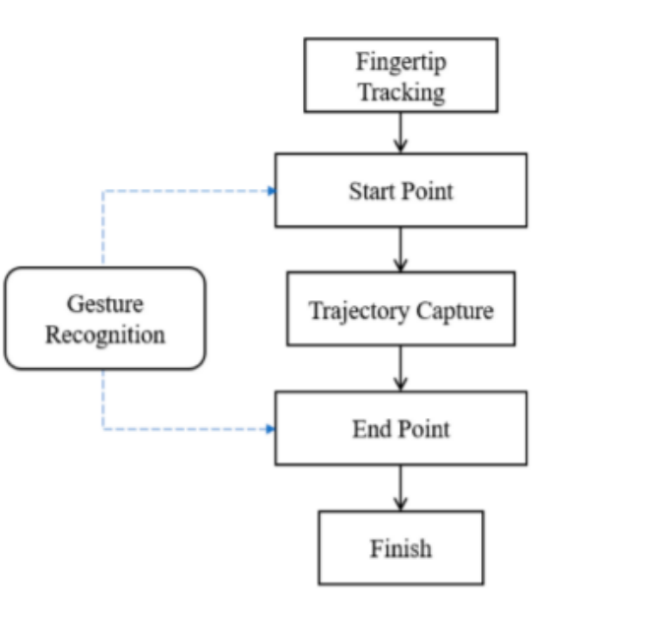

[19] They also develop a special training strategy. The suggested method achieves 94.3% accuracy for 9 gestures and 99.0% accuracy for 5 different hand positions. The problem of matching a photo sequence to a model, which is frequently faced in hand gesture detection, was addressed alternatively by Yang et al. Their suggested approach can work even with inadequate segmentation and is not dependent on skin colour models. To link the segmentation and recognition procedures, they employed a middle grouping approach. Their findings imply that both models benefit from a 5% performance decrease.

Character recognition systems based on finger tracking have been presented by Jari Hannuksela et al., Toshio Asano et al., and Sharad Vikram et al. In this study, the author presents a motion-based tracking system that integrates two Kalman filtering methods with the Expectation Maximisation (EM) strategy. This system seeks to estimate both camera motion and finger motion, which are two separate motions. The estimation method is carried out through examination of the motion traits generated from the scene in each frame. Their research is primarily focused on making it possible to operate a mobile device by gliding a finger in front of a camera. The authors discuss a visual interface designed to recognize Japanese katakana letters in mid-air. They utilize a Light Emission Diode (LED) pen and a TV camera to track hand motion, translating the pen's movement into directional codes. To account for variations in writing speed, the codes are normalized to 100 data points, with 46 Japanese characters defined within them. The character recognition accuracy achieved with a single camera is 92.9%, while the gesture direction accuracy across multiple cameras reaches 90%.

[3] In this system, we employ fingertip detection in conjunction with a machine learning algorithm written in Python, resulting in natural interaction between man and computer. This initiative aims to address several key societal issues.

1. Hearing-impaired people use sign languages to communicate, yet most of the world is unable to understand their emotions and thoughts without translation.

2. Consequences of excessive smartphone use include distractions, mental anguish, accidents, and the emergence of new conditions. Smartphones are admired for their mobility and ease, yet they can also put users in danger of dying.

3. We use a lot of paper for scribbling, writing, drawing, and other activities, therefore the problem of paper waste is not a new one.

The need for 5 litres of water to generate one A4-sized piece of paper, the fact that 93% of writing comes from trees, and the fact that paper waste makes up around 50% of business waste and 25% of landfill space are just a few noteworthy figures that emphasise the environmental impact of paper usage. The introduction of air writing technology can help to solve these environmental problems. Particularly for those who are hard of hearing or deaf, air writing can be a useful communication tool. Their handwritten text can be spoken over or presented using augmented reality. Since there is no need for actual paper and everything is saved digitally, air writing has the benefit of allowing for uninterrupted work. This reduces paper waste and its accompanying environmental impact.

**4. TECHNOLOGY**

## 4.1 About Computer Vision

Understanding picture and video storage, as well as information extraction and processing from these visual data, are all topics covered by computer vision. In terms of artificial intelligence (AI), it serves as a fundamental application. Notably, the importance of computer vision has increased significantly in fields like robots, driverless cars, and image processing applications. Computer vision, a subset of artificial intelligence, allows devices to glean valuable information from digital photos, movies, and other visual sources. By doing this, it gives them the ability to formulate wise recommendations based on the gleaned knowledge. In essence, computer vision gives machines the ability to see, understand, and interpret visual input whereas artificial intelligence gives machines the ability to think.

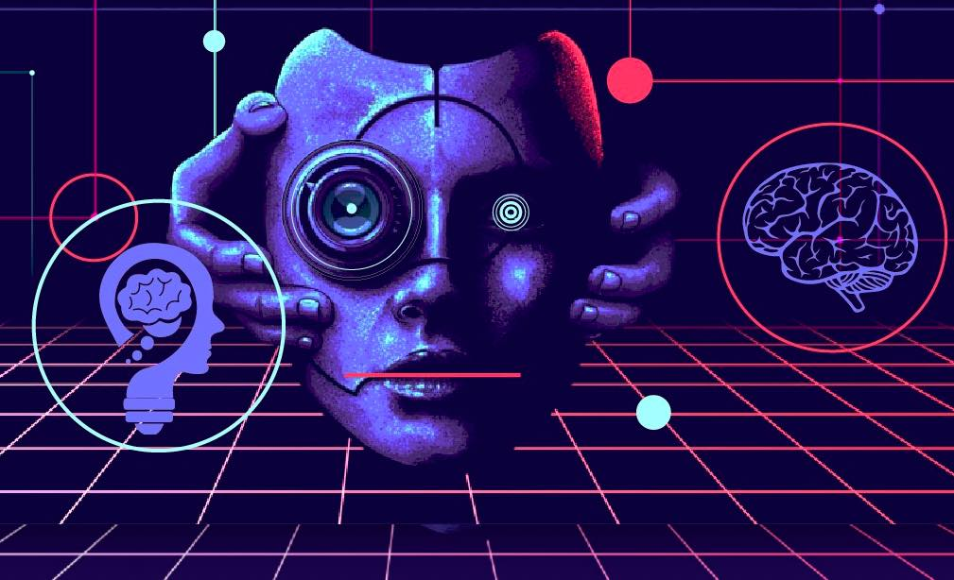

Though humans have some advantages, computer vision functions similarly to human vision. A lifetime of contextual learning helps human vision, allowing us to distinguish between things, gauge their distance from one another, spot motion, and spot anomalies in a scene. Instead of depending on organic components like retinas, optic nerves, and a visual brain, computer vision uses cameras, data, and algorithms to educate robots to execute these tasks in a far shorter amount of time. A computer vision system that is used to check products or keep track of industrial processes can analyse a large number of things or actions per minute and find little faults or problems. However, a lot of data is needed for computer vision. This data is processed and analysed repeatedly until significant differences are found, leading to the eventual achievement of image recognition.

For instance, a sizable dataset of tyre photos and associated data must be provided in order to teach a computer to recognise car tyres. This gives the computer the ability to recognise the differences between various tyre types and finally spot tyres that are not defective.

4.2. **About Open CV**

With its extensive open-source library, Open-CV, activities related to computer vision, machine learning, and image processing are made easier in modern systems. It allows for the analysis of photos and videos in real-world applications, making it possible to recognise objects, people, and even human handwriting. Python may be used to build Open-CV's sequence models and do in-depth studies when paired with additional tools like NumPy. Observed patterns and their unique attributes can be retrieved and identified by using vector space and mathematical operations on these features.

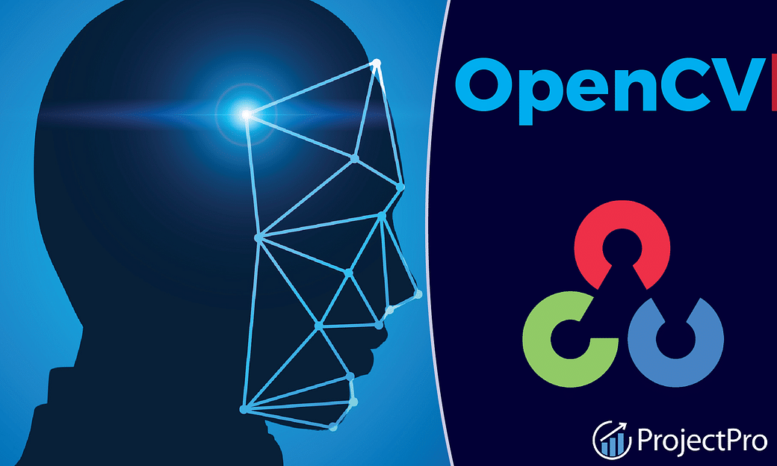

Widely used for computer vision applications such as artificial intelligence, machine learning, and facial recognition is OpenCV, an open-source library created in Python. The name "CV" in OpenCV refers to computer vision, a branch of science that enables machines to understand digital images like pictures and movies. Computer vision's primary goal is to derive useful information from images, such as annotations that can identify objects, annotations, 3D models, and more. These annotations might include the names of numerous items, such as vehicles, traffic signs, and individuals. Utilising computer vision technology, OpenCV makes it easier to recognise and process a variety of items in a variety of applications.

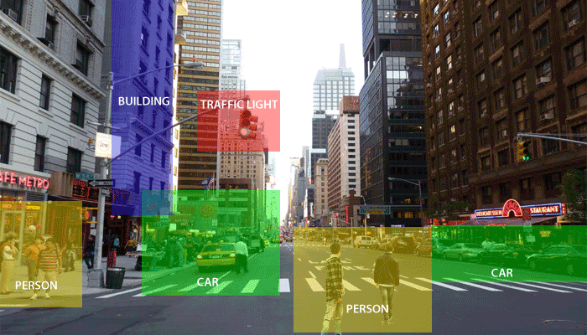

The Computer vision empowers machines to carry out different jobs as meticulously as people can. The listed below are the two primary computer vision tasks are described:

• Classification of objects: A model can recognise and classify new items into the established training categories after being trained on a given dataset of objects.

•Identification of objects : This task requires the model to correctly recognise and differentiate a specific instance of an object..

Working of the Open-CV :

Machines rely on turning this visual input into numerical data and storing it in memory, whereas human eyes supply a large amount of information through visual perception. How computers execute this transformation of images into numbers is the key question. As images are converted into numerical representations in this process, the pixel value is crucial. The smallest component of a digital picture or graphic that can be shown on a digital display device is a pixel. Images can be analysed and interpreted in one of two different ways:

Computer vision makes extensive use of grayscale images, which are distinguished by the absence of colour and the usage of black and white tones. Intensity contrast is used to represent these images, with black being the lowest intensity and white denoting the maximum intensity. Computers assign a value to each pixel in grayscale photos based on the degree of darkness. Grayscaling has a number of benefits, including the below listed ones:

* Grayscale images are one-dimensional as opposed to RGB images, which have three dimensions and three colour channels. Processing and analysing data are made simpler by this reduction in dimensions.
* Reducing complexity of a model: 450 input nodes are needed for training neural networks on RGB images with size like 11x11x4. However, the same neural network may be trained with only 120 input nodes when utilising grayscale photos, which reduces complexity of the model..
* Compatibility with particular algorithms: The OpenCV library's detection of edges function, for example, is specifically made to operate on grayscale images. These techniques can efficiently be used to extract edge information and carry out other processing of image tasks by converting images to grayscale..

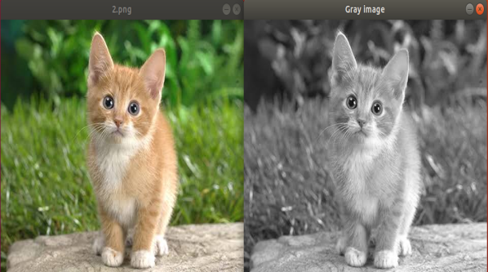

### What are the categories of grayscale?

**Hue**: They change the colour channels of an imputed picture at random, causing the system to evaluate different colour hues for the item. It draws attention to the edges and forms of items rather than their distinct hues.

**Saturation**: It is the process of changing the liveliness of the pixel as well as the colour of the image.

**Brightness**: It ranges from 0 to 100. The deeper the shade, the lower the level, and the brighter the shade, the higher the level. The hues range from black to white.

**2. RGB**: Red, Green, and Blue, or RGB, is a colour paradigm whereby mixing these three primary colours results in a broad variety of hues. The RGB model is essential for representing and interpreting pictures in computer vision. The three distinct image planes that make up each pixel in an RGB image correspond to the intensities of the red, green, and blue channels. The computer saves the data required for further analysis and interpretation by extracting and storing the values of these colour components for each pixel in an array.

Each main colour in the RGB model corresponds to a certain wavelength. The computer determines the overall composition of the colour by adjusting the levels of the red, green, and blue components in accordance with the intended colour. A specific colour within the RGB colour space can be chosen and reproduced by giving the right ratios of these fundamental elements.

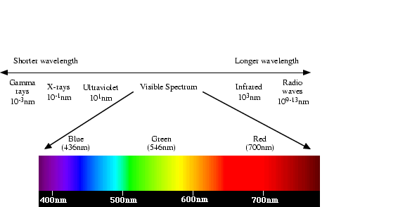

**4.3 ABOUT PYTHON**

Python is a high-level, dynamically interpreted programming language renowned for being object-oriented and having expressive syntax. It is highly suited for many uses, including scripting, prototyping, and integrating existing components because it has a variety of built-in data structures and functionalities. Because of its clear and simple syntax, Python places a high priority on readability, which lowers the cost of maintaining programmes.Python's support for modules and packages is one of its strengths since it enables programmers to write modular, reusable code. Furthermore, the Python interpreter and sizable standard library are open-source, permitting usage and distribution in source and binary versions on a variety of popular platforms. Guido van Rossum planned Python within the late 1980s and early 1990s at the Netherlands' National Investigate Established for Arithmetic and Computer Science.



Python is well known for being a programming language that is especially friendly to newcomers. In fact, it has become so well-liked among beginners that it has surpassed Java as the language that new students use the most frequently. One of the reasons for this is that Python manages a sizable deal of the complexity associated with programming, allowing inexperienced users to concentrate on understanding fundamental programming concepts rather than becoming mired in minute details. This Python feature makes it possible for beginners to study more comprehensively and speeds up their path to becoming knowledgeable programmers.

Python has the following features and benefits:

* Python is well known Cross-platform compatibility: Python is adaptable for many situations since it works with a variety of operating systems.
* Concise and legible syntax: Python's syntax is meant to match the language structures found in English, allowing programmers to write code in less lines than they would in other programming languages. This readability improves the understanding and maintainability of the code.
* Execution via an interpreter: Python makes use of an interpreter system, which enables code execution without the requirement for compilation. This makes rapid prototype and iteration possible, enabling developers to test and improve their ideas right away.

• **APPLICATIONS OF PYTHON**

Python has uses in a variety of industries and academic fields, including:

Python is commonly used to create dynamic webpages, online applications, and APIs in web development. Python comes with built-in tools and modules for writing efficient web code, and frameworks like Django, Flask, and Pyramid speed up web development.

1.**Python's rich ecosystem** of modules and tools makes it a popular choice for data science and analytics. Libraries like SciPy, Pandas, and NumPy provide statistical calculations, data analysis, and data manipulation. Python is also frequently used for projects requiring machine learning and artificial intelligence thanks to packages like Scikit-learn, TensorFlow, and PyTorch. Additional applications of python in web development are:

1. Outstanding visualisation

2. Developmental convenience

3. Increased security

4. Quick development procedure

**2. Python is used in scientific computing**: for applications including mathematical modelling, data visualisation, and numerical simulations. Matplotlib, SciPy, and SymPy libraries are frequently used in engineering and scientific research.Python is excellent for automating repetitive operations, system management, and scripting because of its simplicity and ease of use. It is frequently used for job scheduling, file handling, and batch processing.

**3. Infrastructure and DevOps**: Python is frequently used in DevOps for activities like provisioning infrastructure, deployment automation, and configuration management. Python is used to create programmes such as SaltStack and Ansible. Python is used in game development for game logic development, prototyping, and scripting. For using Python in game development, popular options include the frameworks Pygame and Panda3D.

**4.Python is used in education**: Python is often used in educational establishments to teach programming principles because of its easy-to-read syntax. It is frequently the language of choice for classes on beginner programming.

**5.Trading and Finance**: Python is used in the financial sector for quantitative analysis, risk management, and algorithmic trading. Financial data analysis typically makes use of libraries like Pandas and NumPy.

These instances highlight Python's adaptability, which is used in a variety of fields like artificial intelligence, image processing, natural language processing, cybersecurity, and more. Python is suitable for a variety of applications due to its adaptability, user-friendliness, and strong community support.

**4.4 NumPy IN PYTHON**

NumPy may be a Python library for controlling clusters. It moreover has capacities for working with direct variable-based math, the Fourier change, and lattices. Travis Oliphant outlined NumPy in 2005. It is an opensource venture simply are free to utilize. NumPy is an truncation for Numerical Python.

A popular Python package known as NumPy was created with numerical computing in mind. For effective manipulation and analysis of numerical data, it provides a wide range of features. The ndarray (n-dimensional array), which permits storing and manipulation of sizable, homogenous arrays and matrices, is the core data structure of NumPy. It offers a large array of arithmetic operations that may be applied element-by-element to arrays, including trigonometry, algorithms, and statistics.

**THE NEED FOR NumPy**:

NumPy has a number of noteworthy features, including the ability to broadcast, which facilitates operations between arrays of various forms without the use of explicit loops. This makes code more readable and concise. NumPy's comprehensive support for linear algebra operations, such as matrix multiplication, eigenvalues, and matrix decompositions, is yet another noteworthy feature. These features are essential for many mathematical and scientific computations. As a core part of higher-level libraries like SciPy, Pandas, and scikit-learn, NumPy smoothly integrates with the other libraries in the scientific Python ecosystem. Smooth processes for image processing, machine learning, and data analysis are made possible by this connection.

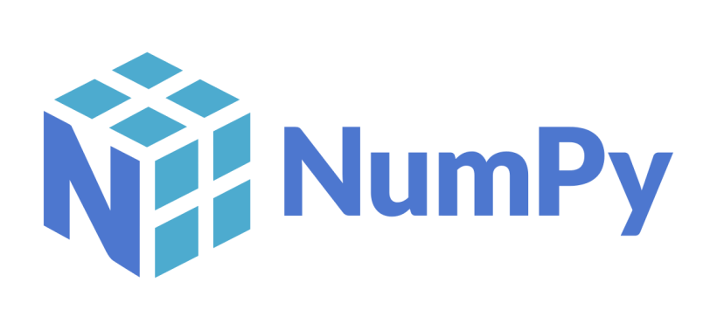

The optimised performance of NumPy is one of its main benefits. It is written in C, which offers faster speed for numerical computations than standard Python lists. Furthermore, NumPy enables vectorized operations, making it possible to write effective code that makes use of hardware acceleration.

Overall, NumPy has numerous uses in areas including image processing, machine learning, scientific research, and data analysis. It is a crucial component of the Python environment for scientific computing due to its capacity for handling enormous datasets and carrying out intricate calculations.

**4.5 ABOUT MACHINE LEARNING**

Within the broader subject of artificial intelligence and computer science, machine learning is a specialised area that uses data and algorithms to simulate human learning processes, gradually increasing its accuracy. Machine learning plays a key role in the rapidly expanding field of data science. Algorithms are trained to produce classifications, predictions, and insightful data during data mining activities using statistical techniques. The decision-making processes within applications and organisations are then informed by these insights, with the goal of influencing key performance indicators and promoting strategic growth.

The need for qualified data scientists is anticipated to increase as the amount and complexity of big data continue to increase. Machine learning could be a basic component of the quickly growing teach of information science. Calculations are instructed utilizing measurable approaches to deliver classifications or forecasts and to discover basic experiences in information mining operations.

**TYPES OF MACHINE LEARNING**

Based on their methodology, machine learning models can be divided into three groups:

**MACHINE LEARNING WITH SUPERVISION:** One of these methods is supervised learning, in which computers are trained using labelled data, in which the input data and associated output labels have previously been matched. The labelled data acts as a manual for the machines so they can learn and correctly forecast the outcome. The training data serves as a supervisor in this process, similar to how a teacher directs a pupil.

Giving the machine learning model exact input-output pairings during the training process is known as supervised learning. A supervised learning algorithm's goal is to identify a mapping function that can successfully translate an input variable (x) into an output variable (y).

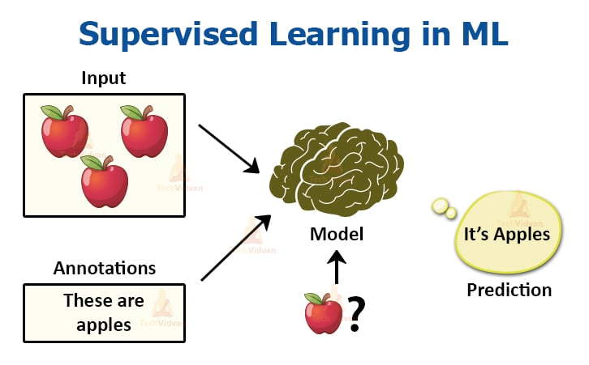

**ADVANTAGES:**

* Supervised learning makes use of prior knowledge to gather and produce data.
* It makes use of specialist knowledge to optimise performance needs.
* There are many real-world computer difficulties that can benefit from supervised machine learning.
* It can handle tasks including classification and regression.
* It makes it possible to map or estimate results for new samples.
* The training data's number of classes can be adjusted based on requirements.

**DISADVANTAGES**:

* The classification of huge data might be difficult for supervised learning.
* Longer processing times are a result of the extensive computing required for training for supervised learning.
* Not all complex machine learning jobs can be handled via supervised learning.
* Supervised learning can have significant computing needs.
* It is dependent on labelled datasets and a training procedure, which could have drawbacks.

**UNSUPERVISED LEARNING**

Unsupervised learning could be a machine learning approach in which models are made without the utilize of a preparing dataset. Building models using machine learning without the use of a labelled training dataset is known as unsupervised learning. Instead, the models sift through the available data to find hidden patterns and insights. It is comparable to how the human brain processes new information during learning. Unsupervised learning is identified by the following characteristics: Unlabeled datasets are used to train models, and they are then given free rein to use them.

Unsupervised learning lacks explicit labels, in contrast to supervised learning, which pairs input data with corresponding output data for regression or classification tasks. Its goals are to identify a dataset's underlying structure, compile comparable instances into groups, and convey it succinctly.

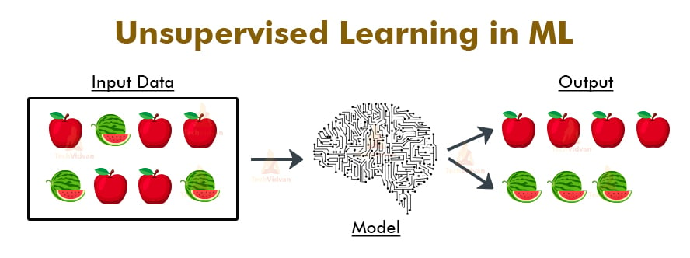

**There are two categories of unsupervised learning algorithms:**

**CLUSTERING:** Identifying natural groups or clusters within a dataset is the process of clustering. Based on their underlying patterns or similarities, it seeks to combine similar instances. Segmenting consumers based on their purchasing patterns is an illustration of a clustering problem.

**ASSOCIATION:** Finding connections or correlations between various variables or items within a dataset is the main goal of association rule learning. Finding patterns where individuals who purchase item ‘A’ also frequently purchase item ‘B’ is one example of the sort of rule that can be used to explain major chunks of the data is the goal.

**Unsupervised learning has the following advantages:**

* + It makes dimensionality reduction jobs easier
  + It does not require labelled training data.
  + Spots patterns in the data that weren't there before.
  + Versatility: Can be used to solve a variety of issues, such as association rule mining, anomaly detection, and clustering.
  + Exploration: Enables the discovery of unusual and potentially valuable patterns in data that may not be immediately obvious.
  + Cost-effective: Because it doesn't rely on labelled data, it requires less time and money than supervised learning**.**

**Disadvantages of unsupervised learning**

* + The lack of specified answers during training makes it difficult to evaluate accuracy or efficacy, which could lead to erroneous findings.
  + User involvement: Manual interpretation and labelling of the identified patterns or clusters are necessary.
  + A lack of direction: Without labelled data, it is difficult to assess the applicability or value of the discovered patterns.
  + Sensitivity to data quality: Problems like missing values, outliers, and noisy data can have an impact on unsupervised learning.
  + Scalability: Complex methods or vast datasets can be computationally expensive, which restricts scalability.

**SEMI-SUPERVISED LEARNING**

Between supervised and unsupervised learning strategies, semi-supervised learning is in the middle. During the training phase, it makes use of both labelled and unlabeled datasets.

Various Semi-supervised Learning Methods:

1.The standard supervised learning approach is used in inductive semi-supervised learning. Using a labelled training dataset, a machine learning model is created and trained. Then, in a testing dataset, labels for unused instances are predicted using the trained model.

2.Transductive semi-supervised learning is a method of learning that takes into account both the training and test datasets. Based on the data gleaned from the combined dataset during the learning phase, the objective is to predict labels for the instances in the testing dataset.

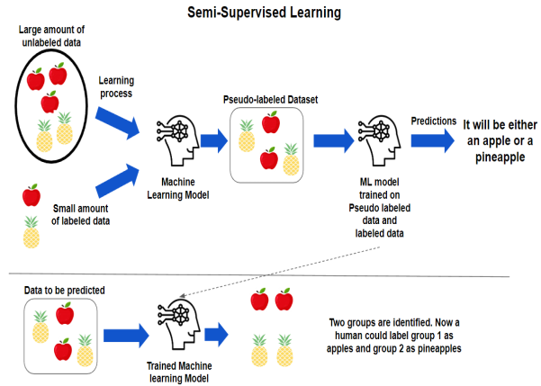

Hence, these are the technologies that are used in our project.

**4.6 METHODOLOGIES**

**4.6.1 FINGERTIP DETECTION**

Fingertip discovery is one of the vital enhancements in movement acknowledgment, however it has small impact on the exactness of movement acknowledgment. To take after or adjust movements in their applications, a few computers vision-based apps have utilized fingers. Fingertip discovery and following is a critical portion of numerous computer vision applications. Fingertip following could be a high-resolution innovation made in 1969 within the field of signal discovery and picture handling that’s utilized to decide the successive area of the user's fingertips. Since fingertip information is basic for video flag affirmation development, an approach for fingertip finding is displayed. To take after or control signals in their applications, a few vision-based apps have utilized fingers.

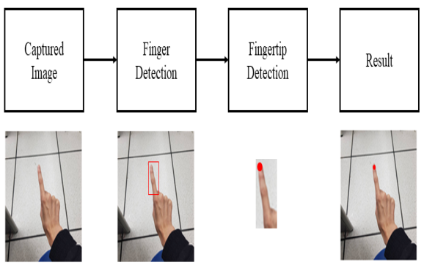

The process of identifying and following the movement of fingertips to communicate with a computer system is known as fingertip detection for human-computer interaction. Users are no longer required to use any handheld devices to interact with a system; they can do it by merely waving their finger in the air. Without the use of a physical pen or stylus, this interaction approach entails writing letters or words in open space using finger or hand gestures. Instead, the fingertip itself is the primary object of our approach's detection and tracking. The capacity to write in the air without having to carry a writing utensil is what we want to give users. To enable this air-writing interaction, we identify the fingertip position in each frame and produce a set of coordinates.

**4.6.2 ABOUT IMAGE PROCESSING**

The process of converting an image into a digital format and applying various operations to it in order to extract useful information is known as image processing. Typically, image processing systems use particular signal processing techniques and treat images as 2D signals. Image processing can be divided into five main categories:

* Finding things or information that might not be evident in the original image is the emphasis of the visualisation category.
* Identification and detection of items or particular features inside an image constitutes recognition.
* Enhancement and restoration: These techniques try to make an image more clear and of higher quality than it was originally.
* Pattern recognition is examining and measuring the structures and patterns that surround items in an image.
* Retrieval: Using the original image's content as a guide, this category enables browsing and searching a vast collection of photos to identify images that are comparable.

.

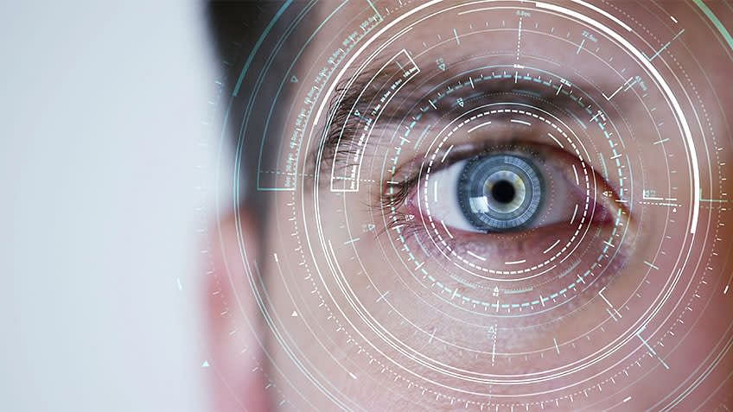

**4.6.3 ALGORITHM OF WORKFLOW**

There are various steps involved in the picture processing process:

1.For better colour detection, reading and converting frames to the HSV colour system.

the canvas frame is ready, and the proper ink buttons are added.

2.Track bar values can be changed to determine the mask for the coloured marker.

3. Applying erosion and dilation morphological techniques to the mask.

4.Finding the largest contour's centre coordinates and saving them in an array for use in later frames (arrays for painting points on the canvas) are all steps in the contour detection process.

5. Creating point arrays on the canvas and the frames

Writing entails several capabilities. As a result, the number of gestures needed to manage the system equals the number of activities involved. Our system's core functions are as follows:

**1. Writing Mode**: The system will trace and preserve fingertip coordinates in this mode.

**2. Colour Mode** - The user has the ability to change the text's colour from the palette that is offered.

**3. Backspace** - Suppose a user makes a mistake and we need to provide a quick backspace motion.

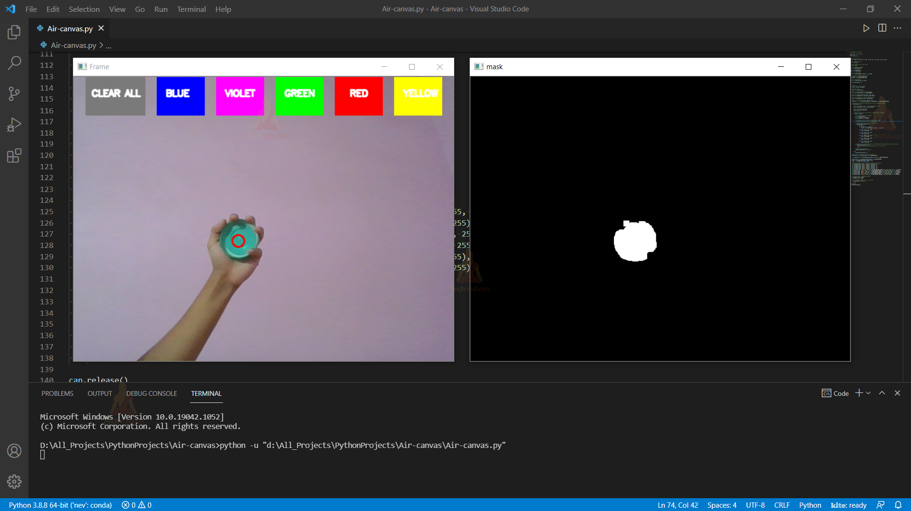

**5. DESIGN REQUIREMENT ENGINEERING**

**WHAT ARE UML DIAGRAMS:**

A graphical representation method for displaying the structure, design, and execution of complex software systems is called the Unified Modelling Language (UML). Maintaining the relationships and hierarchies within an application with hundreds of lines of code can be difficult while developing software. The software system can be broken down into components and subcomponents using UML diagrams. The key system elements, roles, actions, artefacts, or classes are represented in these diagrams, which are based on the Unified Modelling Language. This makes it easier to understand, update, manage, or document system data.

**WHY SHOULD WE USE UML:**

The vast majority of software engineers will comprehend and be able to utilise UML because it is a standard modelling language that can be used with a variety of programming languages and development methods. Despite the fact that many engineers detest diagrams, they are useful in an agile development environment since they speed up and simplify work. Consider UML diagrams to be necessary parts of documentation, not just "nice to have" items.

* + Use UML diagrams to quickly acclimatise new team members or engineers switching teams.
  + Explore the source code.
  + Before starting development, think through new features.
  + Easily communicate with audiences who are both technical and non-technical.

**ABOUT ACTIVITY DIAGRAM**

Similar to a flowchart, an activity diagram serves as a visual depiction of the sequential flow from one activity to another within a system. A system operation is represented by each activity, and the control flow determines how one operation leads to the next. Activity diagrams include features like forks and joins to handle various sorts of flow control, whether the flow is sequential, branching, or concurrent.

Activity diagrams are used in both forward and reverse engineering to create executable systems as well as to visualise the dynamic behaviour of a system. At various levels of abstraction, the diagrams offer a thorough perspective of how activities are set up to supply a service**.** They are especially helpful for demonstrating how operations must be coordinated within a use case or when several tasks must be synchronised because they overlap. The exchange of messages is the sole feature absent from activity diagrams.

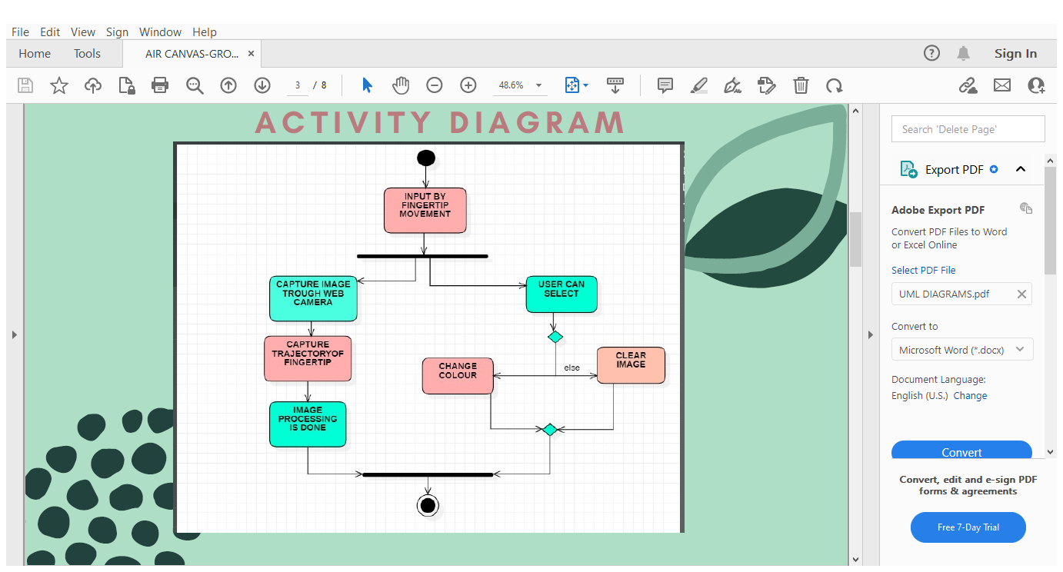

**FIGURE:5.1 ACTIVITY DIAGRAM**

**In figure 5.1** we describe the activity of our project. This figure describes flow from one activity to another.Here first the input image is captured through the webcam then comes the next activity where the fingertip trajectory is dectected and captured and the image is then processed.Next, the user can select to perform ay activity between writing, changing colours or erasing the images on screen. This whole process is depicted through the above image.

This is the activity displayed by our system.

**ABOUT USE CASE DIAGRAM**

Through the addition of use cases, actors, and their interactions, a use case diagram is used to demonstrate the dynamic behaviour of a system. It acts as a simulation of the duties, offerings, and features that a system or component of an application ought to offer. The figure gives a high-level overview of the system's functionality and user interface. Its main goal is to gather the system's requirements, including both internal and external inputs, in order to represent the system's dynamic character.

Relationships between the actors, elements, and other entities in charge of carrying out use cases are established in a use case diagram. It illustrates how outside parties interact with system parts.

The following succinctly describes the purposes of a use case diagram:

* Compiling system requirements.
* Displaying the outside-looking view of the system.
* Identifying the system's external and internal impacts.
* Illustrating the interactions of the actors inside the system**.**

**The below figure 5.2** is the use case diagram for our system. Here the user, server and the webcam are the actors and we have to use case represented by “ovals”. Here the boundary being the system, use cases are assigned to the respective actors according to their needs.

It shows the interaction between the actors as well as it depicts the complete view of the system. The figures shows different symbols, where:

The people who are actively participating in utilising the use cases are represented by stick figures called actors in a use case diagram. Lines or connectors are used to show the relationships between actors and use cases.

The below is the process that involves the actors and describes the use case diagram.

1.To begin the creation of libraries and creating a window frame along with the drawing tools is done by the server.

2.Then the webcam captures the finger trajectory. Here the input is taken through the user. This shows the interaction between the webcam and the user.

3.Lastly the image processing is done by the server and the image is displayed on the screen.

The figure below is the use case diagram for our system.

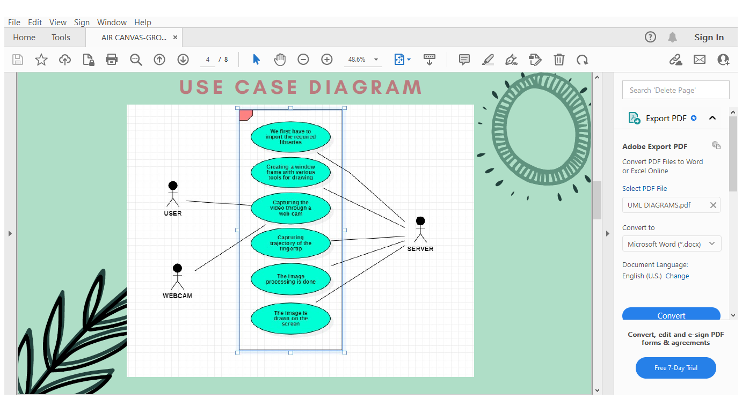

**FIGURE 5.2 USE CASE DIAGRAM**

**ABOUT SEQUENCE DIAGRAM**

A sequence diagram, which is another name for an event diagram, is a visual representation that shows the chronological order of messages delivered and received by various system components or lifelines. It offers a visual representation of the system's dynamic interactions and teamwork. A lifeline in UML is symbolised by a vertical bar, and the flow of messages is shown by vertical dotted lines that cross the diagram's bottom. Sequence diagrams can describe iterations and branching within a system by capturing both sequential and concurrent actions.

**PURPOSE OF A SEQUENCE DIAGRAM**

1.A Sequence Diagram is used to describe high-level interactions among active components in a system.

2.It models different interactions.

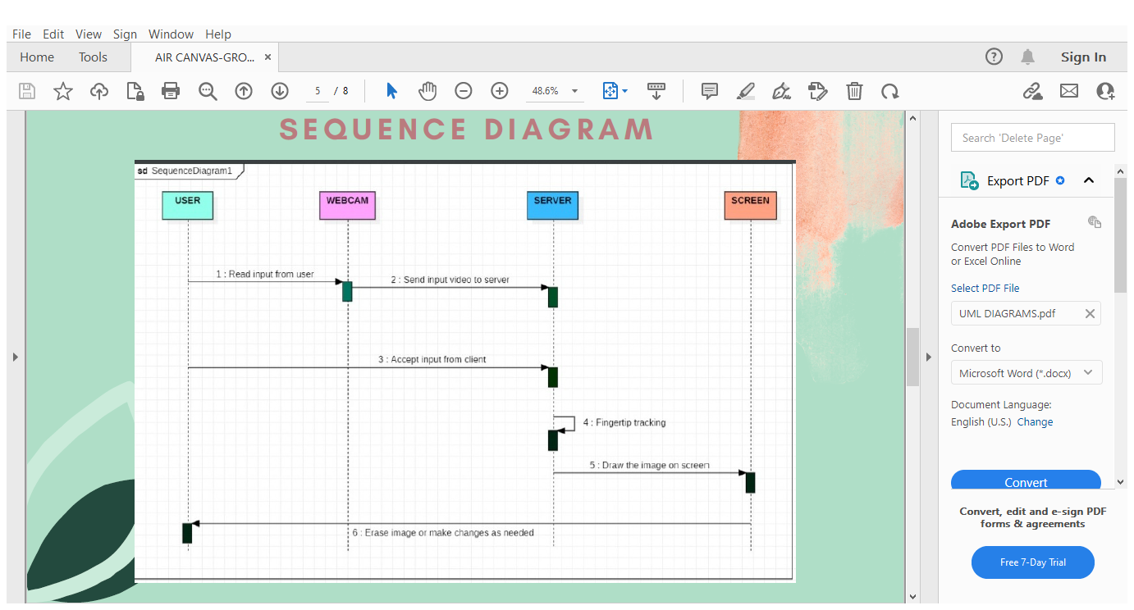

**FIGURE 5.3 SEQUENCE DIAGRAM**

**Figure 5.3** the message flow in the system. We have several notations, which are as follows depicts:

**Lifelines –** They are named elements that depict an individual participant in a sequence diagram.

**Figure** - We show a lifeline in the shape of a skull, along with its name and kind. The head is perched above a vertical dashed line.

**Messages** - Messages are used to illustrate communication between things. The messages show on the lifeline in chronological sequence. We use arrows to symbolise messages.

**DATAFLOW DIAGRAM**

A data flow diagram (DFD) is a picture that shows how information moves through a system or process. With the use of standardised symbols like rectangles, circles, and arrows as well as clear text labels, it illustrates how data is moved between inputs, outputs, storage places, and the connections between each of these components. Data flow diagrams can range from straightforward, hand-drawn summaries of procedures to intricate, multi-level illustrations that go deep into the details of data processing. They perform a number of functions, including as analysing the operation of current systems and simulating them.

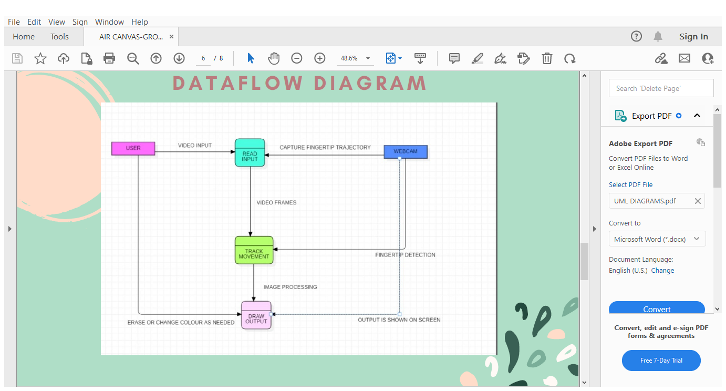

**FIGURE 5.4 DATAFLOW DIAGRAM**

**In the figure 5.4** The data flow in the system is detailed. Among the notations are:

Process - A data flow diagram (DFD)'s ability to modify or alter data flows is referred to as a process. The diagram's rectangular boxes stand in for processes, which are in charge of converting input data into output data. They operate as the fundamental elements that manipulate the data.

Entities that are external to the system being diagrammed are referred to as external entities, actors, sources, sinks, or terminators. They engage with the system by producing or consuming data that is exchanged between the system and an external entity. Unlike processes, external entities just operate as data sources or destinations and do not alter or manipulate the data in any way.

Data Flow: The transfer of data between various system elements, including external entities, processes, and data repositories, is referred to as data flow. In the data flow diagram, arrow symbols are used to represent it and show the direction of flow. Data can be expressed verbally, electronically, or in written form. The arrows have names written beside them that match to the kind of data they represent, as well as any associated processes or data storage.

**SYSTEM ARCHITECTURE DIAGRAM**

Framework engineering charts portray the numerous components of a framework and how they communicate and connected with one another. The framework engineering graph is a theoretical representation of the component design of the framework. It gives a brief clarification of the system's component design to help with component-component associations and framework operation.

A system's plan reflects how it is used and how it interatomic with other frameworks and the exterior environment. It indicates the interconnecting of all framework components as well as the information interface that interfaces them. A system's design speaks to how it is thought of in terms of its structure, capacities, and linkages. The term "framework" in engineering for the most part alludes to the architecture of the computer program instead of the genuine structure of the buildings or machines. A system's engineering reflects how it is used and so advances as the framework is utilized. For illustration, an airplane terminal may be made with engineering that places the control tower and take-offs relax within the same building, however the control tower is found advance absent within the same airport.

As a result, the framework is continuously characterised in terms of its components and their intuitive. So also, information is continuously characterised in terms of the pieces that make it up and the activities that make it usable to a conclusion client.

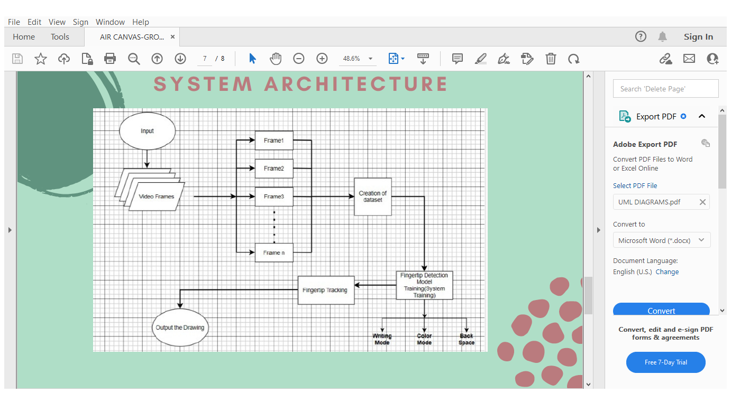

**FIGURE 5.5 ARCHITECTURE DIAGRAM**

**In the figure5.5** the system architecture is shown, we first take the input from the user and the input video is then broken down into various parts called as “frames”. These frames are used to create a dataset. Later the trajectory of the fingertip is detected and the output is shown on the screen.

Here we have the three modes writing, color mode and back space which are included in the window for the user to use.

Hence, this is the complete system architecture of our system.

**6.IMPLEMENTATION**

**6.1. Modules**

**VS Code:**

Visual Studio Code is a free, lightweight, yet powerful source code editor that runs on your desktop and on the internet and is available for Windows, macOS, Linux, and Raspberry Pi OS. It includes built-in support for JavaScript, TypeScript, and Node.js, as well as a rich environment of extensions for other programming dialects (such as C++, C#, Java, Python, PHP, and Go), runtimes (such as.NET and Solidarity), situations (such as Docker and Kubernetes), and clouds (such as Amazon Web Services, Microsoft Azure, and Google Cloud Stage).

**NumPy:**

NumPy could be a Python bundle for cluster handling. It incorporates a high-performance multidimensional cluster protest as well as utilities for controlling them. Typically a foundational Python bundle that includes back for enormous, multi-dimensional arrays and lattices, as well as a tremendous library of high-level numerical strategies to function on these clusters.

**OpenCV:**

OpenCV is a fantastic open-source toolkit for computer vision, machine learning, and image processing. It now has a significant role in real-time operation, which is crucial in modern frameworks. By using it, one may prepare videos or images to recognise items, faces, or even a human's handwriting. Python is capable of managing the OpenCV cluster structure for analysis when it collaborates with other libraries, such as NumPy. We use vector space and apply numerical operations to these highlights in order to distinguish image design and its various highlights.

**Deque:**

Double ended queue or Deque could be a straight information structure in which able to embed or expel components from both its closes i.e. It bolsters final in first out (LIFO) operations as well as to begin with in first out (FIFO) operations. Deque module may be a portion of collections library in python and we will perform inclusion, cancellation or checking the number of components within the deque utilizing the inbuilt strategies within the deque module. In this article, we are going attempt to get it the deque module by executing programs in python.

**6.2. Sample Code:**

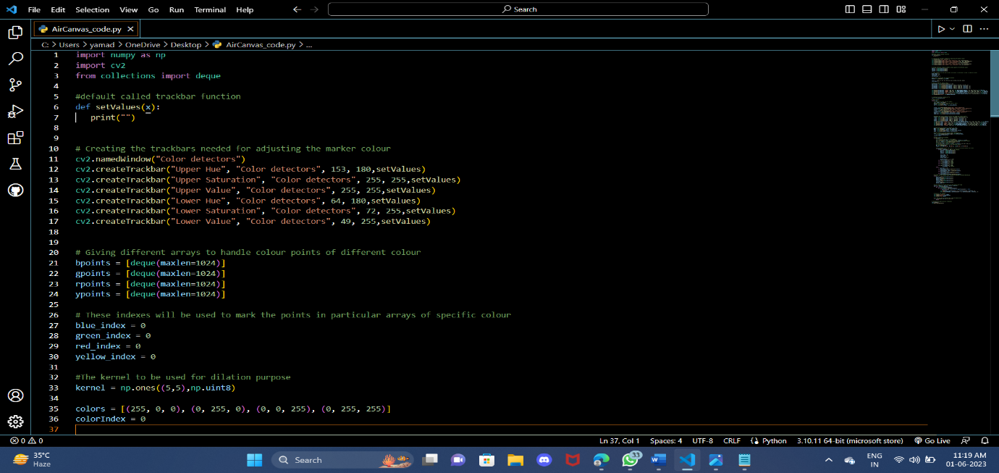

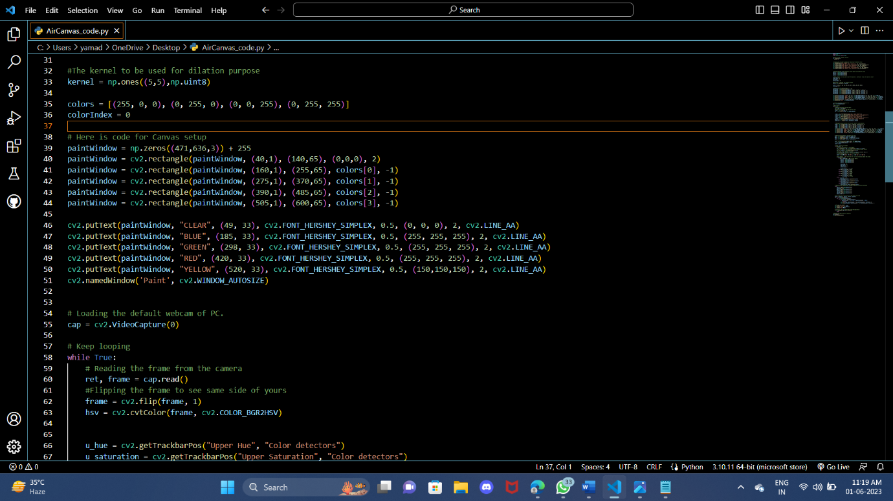

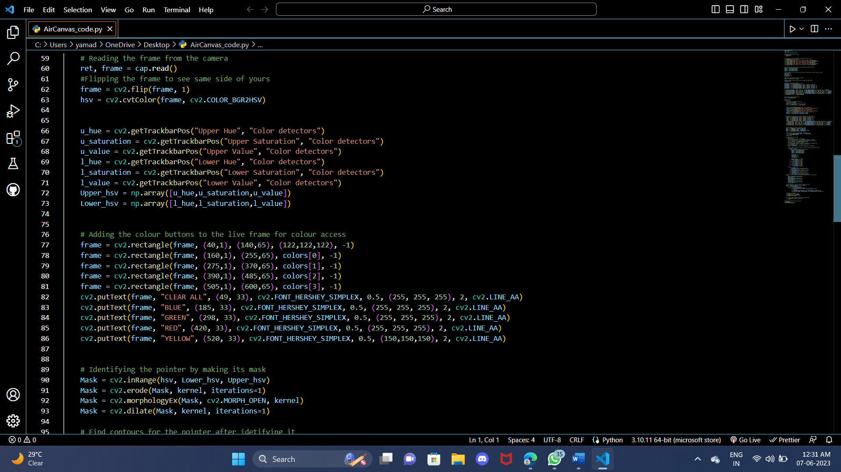

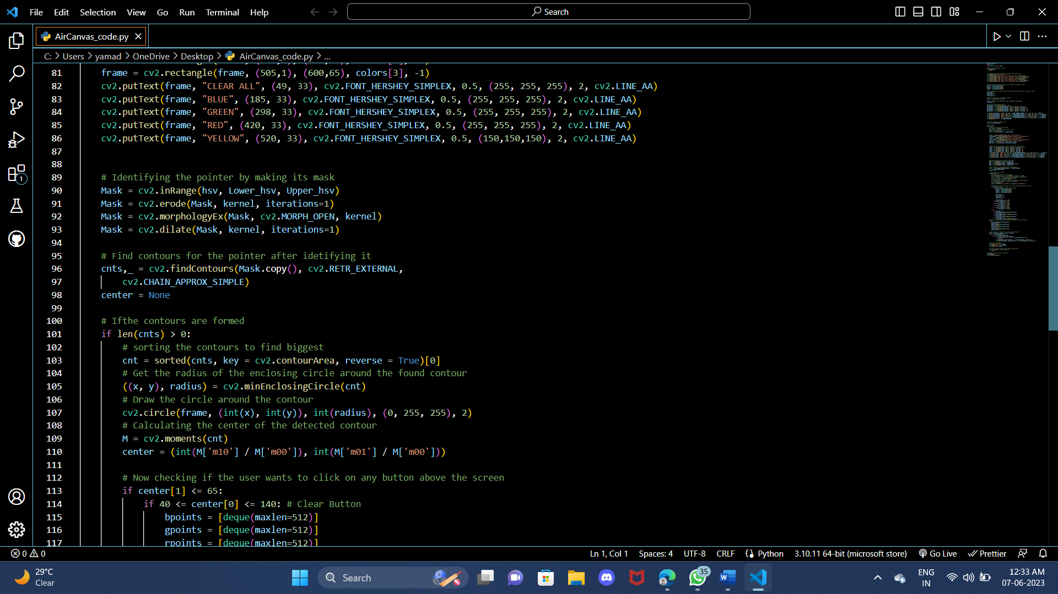

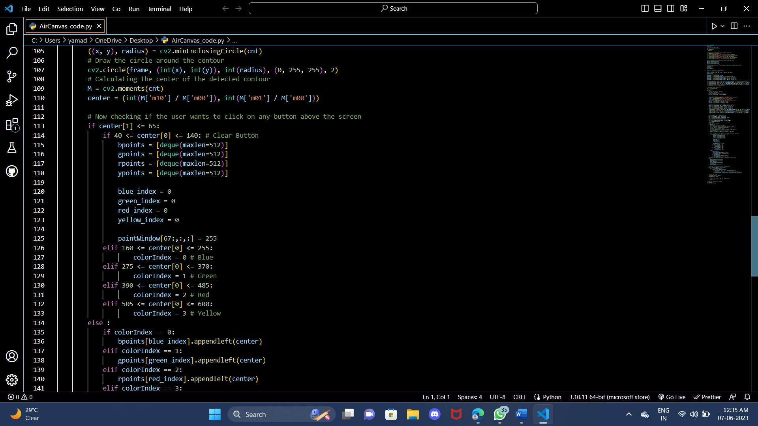

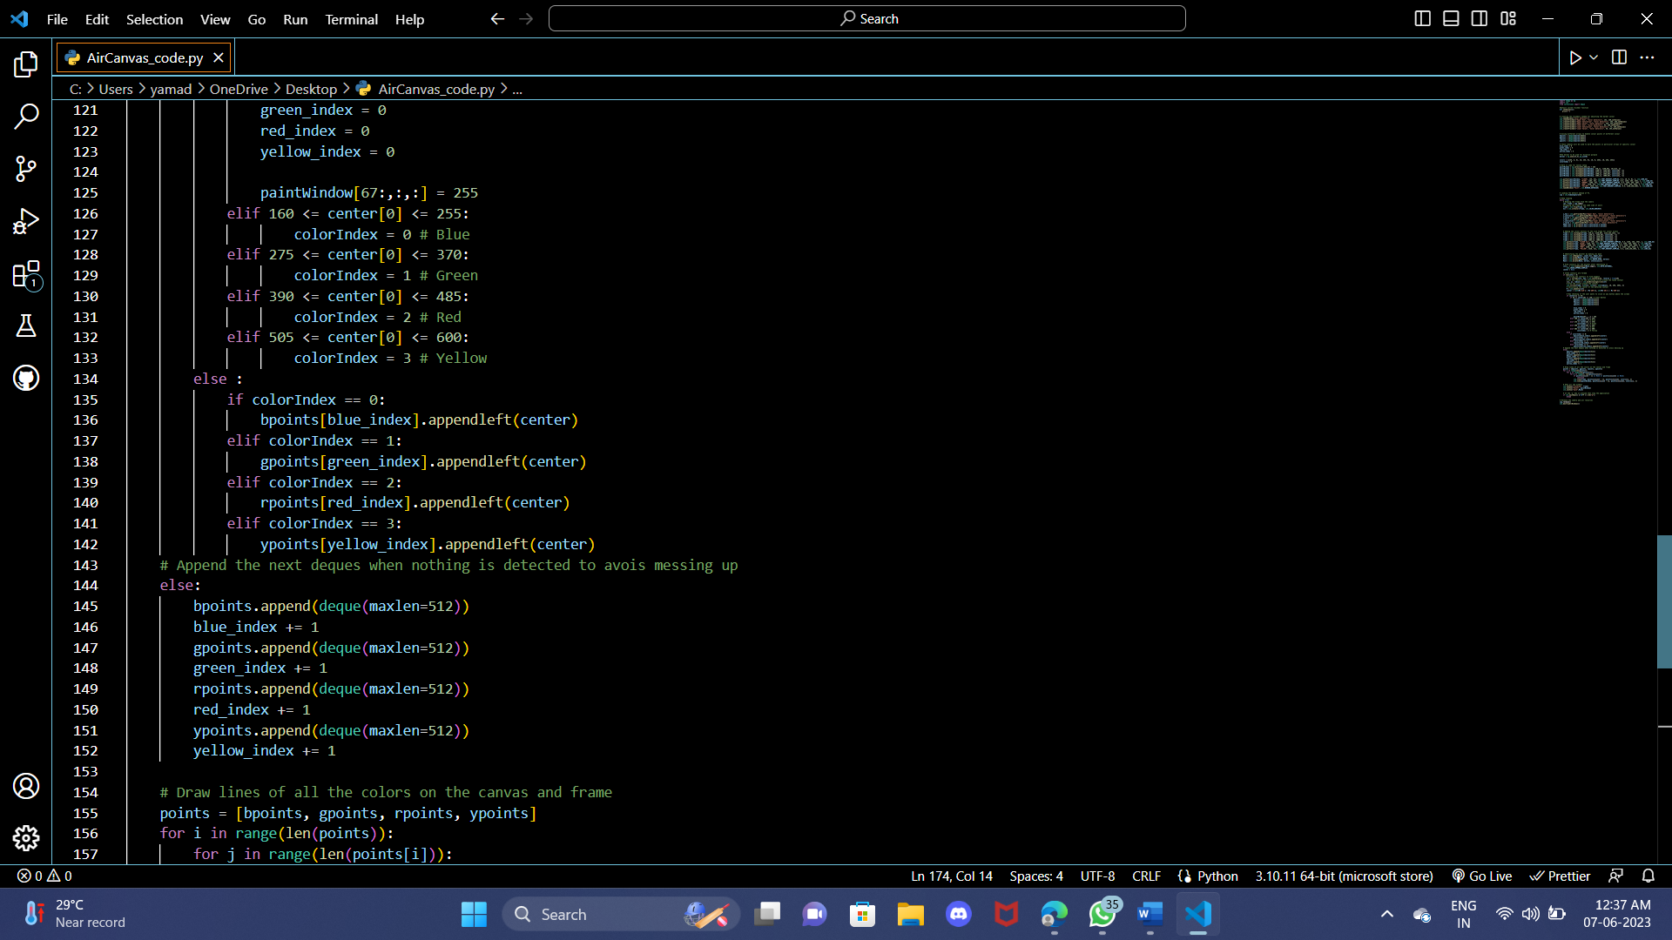

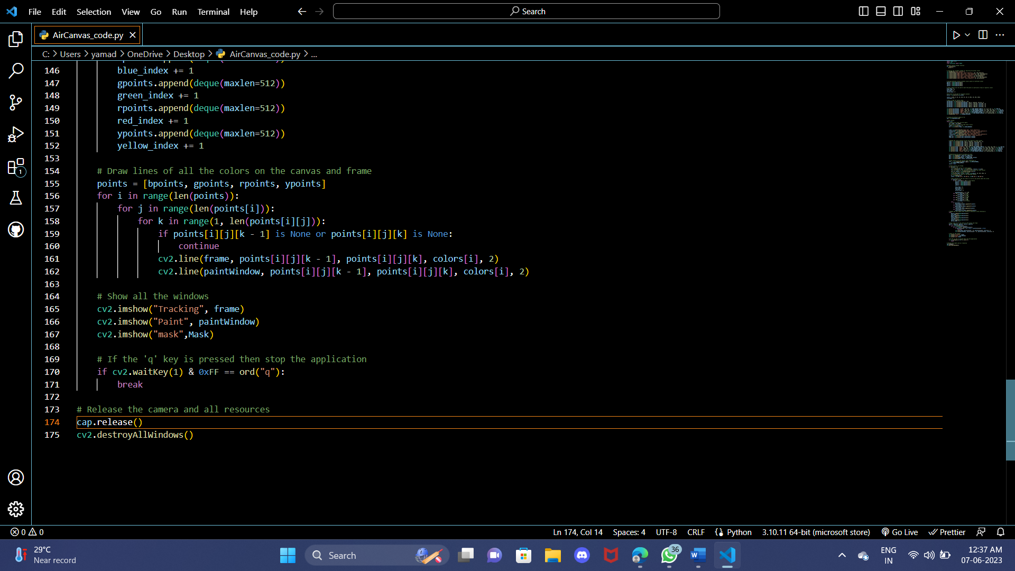

**7. SOFTWARE TESTING**

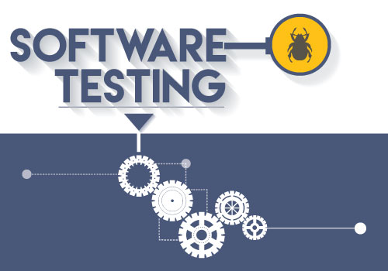

**Figure 16.** Software Testing

**7.1 Unit Testing:**

Modules built from the framework plan undergo validation through the use of unit testing. Each parcel is built using inputs for certain modules. Each module is incorporated into a larger unit throughout the unit testing process. The venture concept and coding have been fully tested at each level. The module interface is tested during testing to ensure that data enters and exits the software unit properly. Analysing the neighbourhood information structure ensures that the algorithm's execution doesn't compromise the accuracy of the quickly obtained yield information. At the end, all error-handling techniques are also tested.

**7.2 Integration Testing:**

Framework testing is ordinarily utilized to recognize blunders caused by unexpected intuitive between sub-system and framework components. After the source code is created, program must be tried to find and redress all conceivable mistakes some time recently being sent to clients. To distinguish blunders, a grouping of test cases must be made, with the objective of revealing all conceivable mistakes. This prepare can be carried out employing a assortment of program instruments. These strategies offer efficient course for making tests that work out the inner rationale of computer program components as well as the input and yield spaces of a program to discover blunders in its work, conduct, and execution. We utilize two approaches to test the computer program: Testing in a White Box: This test case plan method is utilized to work out inside program rationale. Dark Box testing: Computer program prerequisites are worked out utilizing this test case plan methods. Both procedures offer assistance in finding most extreme number of blunders with negligible exertion and time.

**7.3 Acceptance Testing:**

The larger topic of confirmation and approval may include the testing procedure as a subset. In order to satisfy the customer's needs, we must recognise the specifics of the framework, put out every effort, and confirm and accept the item for this very reason. Confirmation and approval are two different concepts. One is done to ensure that the programme accurately implements a certain usefulness, while the other is done to ensure that the product satisfies the needs of the customer. The extension's compliance with all of our project's requirements and specifications was validated. We made it quite clear that our endeavour met the expectations we set at the beginning of our long-term development.

**7.4 White Box Testing:**

Software testers who are familiar with the inner workings, structure, and language of the software—or at the at least, who are aware of what it is meant to do—can conduct white box testing. It has a purpose. It is used to examine areas that are off-limits at the black box level.

**7.5 Black Box Testing:**

Testing computer program in a "dark box" is doing so without having any information of the internal workings, design, or dialect of the module being tried. Dark box tests, just like the larger part of other sorts of tests, must be made from a clear source report, such as a specification or requirements record. It may be a sort of testing where the computer program being tried is taken care of like a dark box. It is inconceivable to "see" interior. Without taking into consideration how the program capacities, the test produces inputs and reacts to yields.

**7.6 Testing on our System:**

Each demonstrate includes the coding portion and the testing portion since they are the two vital things for completing a framework effectively. Our code contains python code which is for anticipating the monkeypox malady from the assembled information. The calculations which we are utilizing are VGG16 which could be a adjusted and profound convolutional neural systems (DCNN) calculation in which they experience Dark Box testing. We have as of now examined the modules utilized in our venture these modules will experience unit testing in our system.

The dataset which contains information approximately 1000+ monkeypox and ordinary information which is our input and anticipating monkey pox from given input is our yield includes different sorts of testing in our framework. Integration testing will be there for checking the program necessities of our framework, it sees whether our framework has capacity to induce the specified yield. It'll test Slam, OS, libraries required for handle the code, coding stage whether it has capability to induce the code without any mistakes particularly compile time blunders and numerous other program necessities. From allotting the way of input, including required header records and libraries, distinctive factors for each handle included.

**8. RESULTS**

* We created a simple output using web-cam with various options for the user to select the desired colour. The position of the colour box with placed.
* After selecting the colour an automatic list is created with the coordinates where ever our hand is moving in the screen, it gets stored in list to give a collections of pixels as generated output.
* The output generates two screens one to help webcam to gather information about the movement of our hand and subsequent tracking hand the other one is a blank white screen to print that movement.

8.1. Colour Detectors:

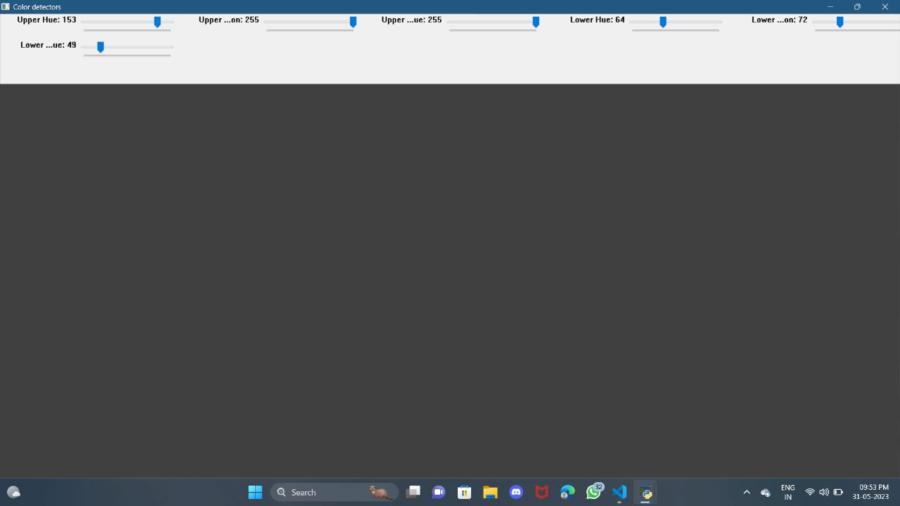

**Figure 17.** Colour Detectors

We created a simple output using web-cam with various options for the user to select the desired colour. The position of the colour box with placed.

8.2. Mask:

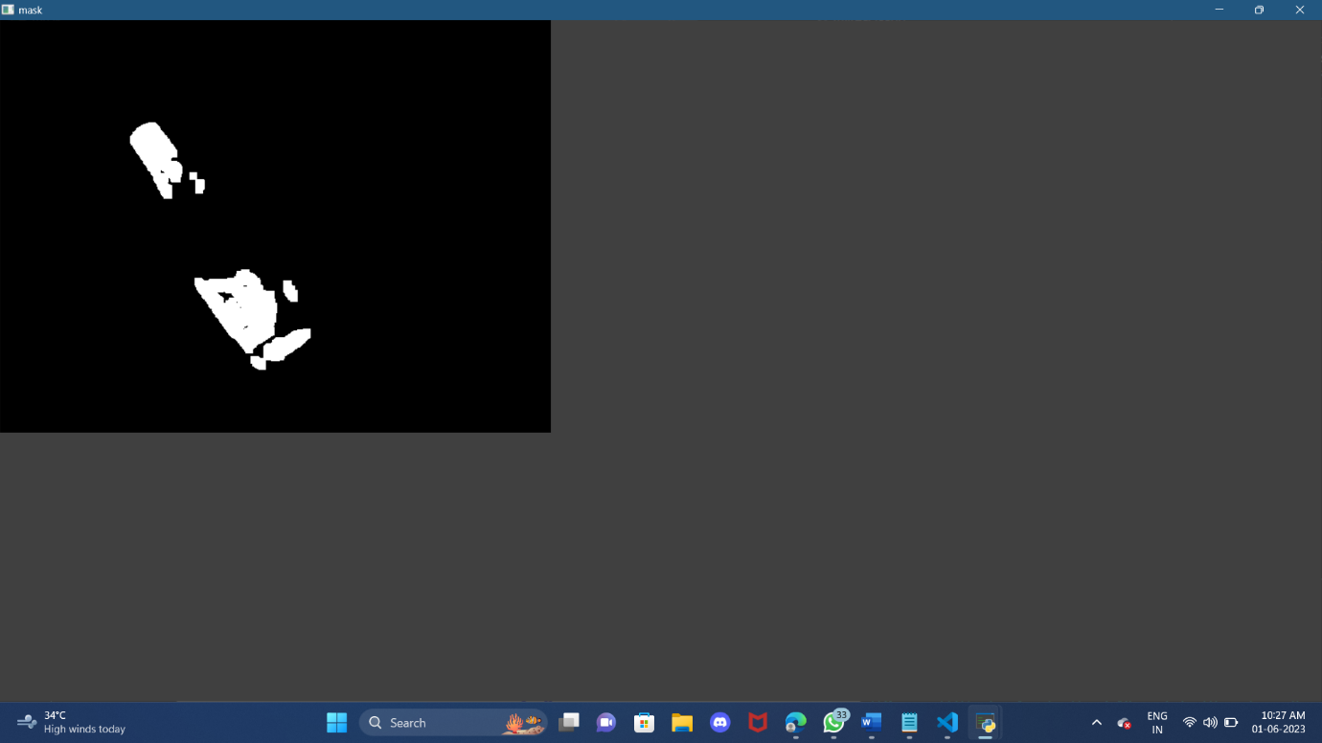

**Figure 18.** Mask

8.3. Tracking: 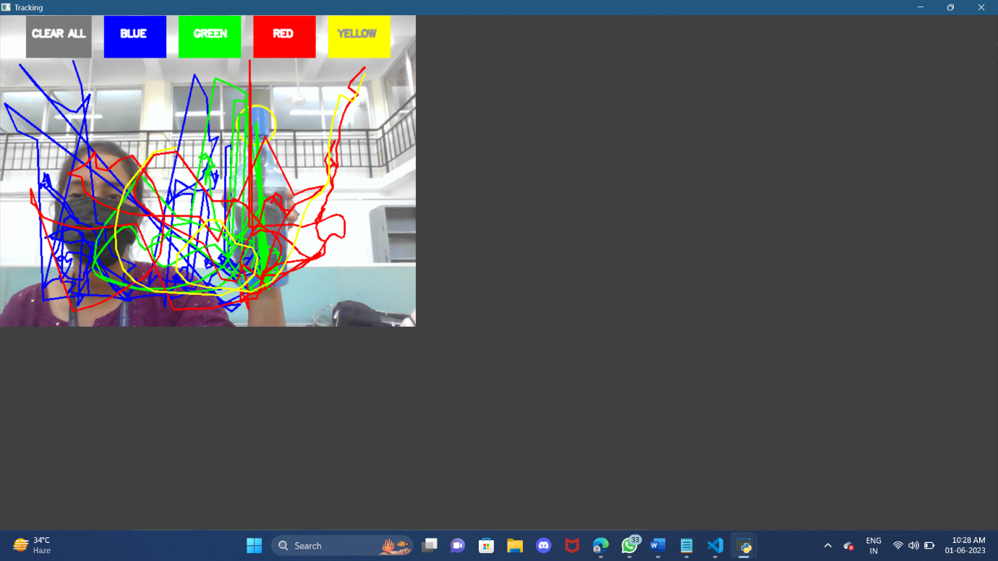

**Figure 19.** Tracking

In the context of drawing applications, a "tracking window" could potentially refer to a feature or interface that allows users to track the movement or position of their drawing tools or stylus within the application.

8.4. Paint:

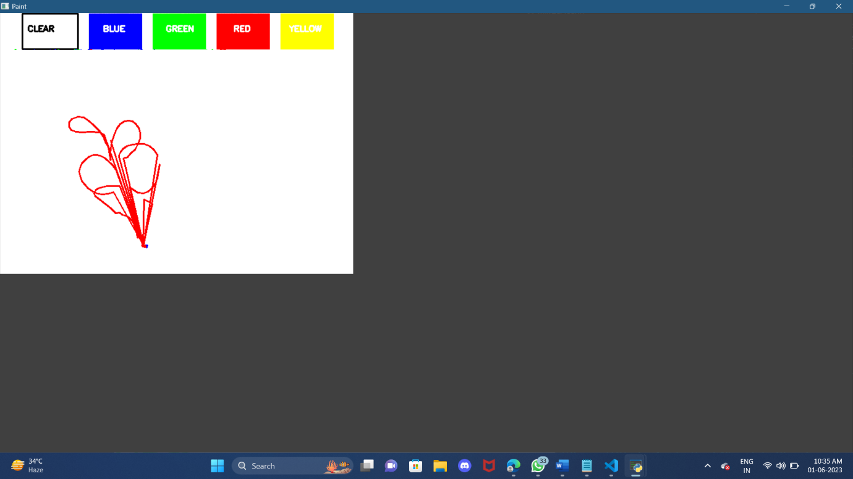

In general, a "paint window" in a drawing application typically refers to the main interface where users can access various painting tools, select colours, clear the drawing, and perform actual drawing or painting on the canvas. This window often includes a toolbar or panel with options for choosing different colours from a colour palette, and accessing other relevant tools or features.

**9. CONCLUSION AND FUTURE ENHANCEMENTS**

**9.1 Conclusion**

This system can make writing conventions obsolete. As a result, making notes while on the go becomes simple as you don't need to have your phone in your hand. It will also be extremely beneficial to promote communication for those with special needs. The system will be easy to use even for old people or anyone who have trouble using a keyboard. In the near future, this system may potentially be used to manage IoT devices, broadening its possibilities. Another option is to draw air in. This technique would make excellent software for wearable smart devices that improve user interaction with the digital environment. Text may come to life via augmented reality.

**9.2 Future enhancements**

Implementing this project can assist in the following ways:

1. An efficient communication technique that decreases mobile and laptop usage by removing the need for writing. The system's primary function is as a potent mode of communication for the deaf.

2. It facilitates effective communication for those who have hearing loss.

3. A variety of uses, including sending emails, text messages, and other types of correspondence using the created text.

The system has various drawbacks that can be fixed in the future. First off, word-by-word writing with a handwriting recognizer rather than a character recognizer will enable speedier writing. Second, instead of utilising the keyboard, hand motions with a pause can be employed to operate the real-time system.

**10. BIBLIOGRAPHY**

[1] Y. Huang, X. Liu, X. Zhang, and L. Jin, "A Pointing Gesture Based Egocentric Interaction System: Dataset, Approach, and Application," 2016 IEEE Conference on Computer Vision and Pattern Recognition Workshops (CVPRW), Las Vegas, NV, pp. 370-377, 2016.

[2] P. Ramasamy, G. Prabhu, and R. Srinivasan, "An economical air writing system is converting finger movements to text using a web camera," 2016 International Conference on Recent Trends in Information Technology (ICRTIT), Chennai, pp. 1-6, 2016.

[3] Saira Beg, M. Fahad Khan and Faisal Baig, "Text Writing in Air," Journal of Information Display Volume 14, Issue 4, 2013

[4] Alper Yilmaz, Omar Javed, Mubarak Shah, "Object Tracking: A Survey", ACM Computer Survey. Vol. 38, Issue. 4, Article 13, Pp. 1-45, 2006

[5] Yuan-Hsiang Chang, Chen-Ming Chang, "Automatic Hand-Pose Trajectory Tracking System Using Video Sequences", INTECH, pp. 132- 152, Croatia, 2010

[6] Erik B. Sudderth, Michael I. Mandel, William T. Freeman, Alan S. Willsky, "Visual Hand Tracking Using Nonparametric Belief Propagation", MIT Laboratory for Information & Decision Systems Technical Report P2603, Presented at IEEE CVPR Workshop on Generative Model-Based Vision, Pp. 1-9, 2004

[7] T. Grossman, R. Balakrishnan, G. Kurtenbach, G. Fitzmaurice, A. Khan, and B. Buxton, "Creating Principal 3D Curves with Digital Tape Drawing," Proc. Conf. Human Factors Computing Systems (CHI' 02), pp. 121- 128, 2002.

[8] T. A. C. Bragatto, G. I. S. Ruas, M. V. Lamar, "Real-time Video-Based Finger Spelling Recognition System Using Low Computational Complexity Artificial Neural Networks", IEEE ITS, pp. 393-397, 2006

[9] Yusuke Araga, Makoto Shirabayashi, Keishi Kaida, Hiroomi Hikawa, "Real Time Gesture Recognition System Using Posture Classifier and Jordan Recurrent Neural Network", IEEE World Congress on Computational Intelligence, Brisbane, Australia, 2012

[10] Ruiduo Yang, Sudeep Sarkar, "Coupled grouping and tching for sign and gesture recognition", Computer Vision and Image Understanding, Elsevier, 2008

[11] R. Wang, S. Paris, and J. Popovic, "6D hands: marker less and-tracking for computer-aided design," in Proc. 24th Ann. ACM Symp. User Interface Softw. Technol., 2011, pp. 549–558.

[12] Maryam Khosravi Nahouji, "2D Finger Motion Tracking, Implementation for Android Based Smart phones", Master's Thesis, CHALMERS Applied Information Technology,2012, pp 1-48

[13] EshedOhn-Bar, Mohan Manubhai Trivedi, "Hand Gesture Recognition in Real-Time for Automotive Interfaces," IEEE Transactions on Intelligent Transportation Systems, VOL. 15, NO. 6, December 2014, pp 2368-2377

[14] P. Ramasamy, G. Prabhu, and R. Srinivasan, "An economical air writing system is converting finger movements to text using a web camera," 2016 International Conference on Recent Trends in Information Technology (ICRTIT), Chennai, 2016, pp. 1- 6.

[15] Kenji Oka, Yoichi Sato, and Hideki Koike, "Real-Time Fingertip Tracking and Gesture Recognition," IEEE Computer Graphics and Applications, 2002, pp.64-71.

[16] H.M. Cooper, "Sign Language Recognition: Generalising to More Complex Corpora", Ph.D. Thesis, Centre for Vision, Speech and Signal Processing Faculty of Engineering and Physical Sciences, University of Surrey, UK, 2012

[17] Y. Huang, X. Liu, X. Zhang, and L. Jin, "A Pointing Gesture Based Egocentric Interaction System: Dataset, Approach, and Application," 2016 IEEE Conference on Computer Vision and Pattern Recognition Workshops (CVPRW), Las Vegas, NV, pp. 370-377, 2016

[18] Vladimir I. Pavlovic, Rajeev Sharma, and Thomas S. Huang, "Visual Interpretation of Hand Gestures for Human-Computer Interaction: A Review," IEEE Transactions on Pattern Analysis and Machine Intelligence, VOL. 19, NO. 7, JULY 1997, pp.677-695

[19] Guo-Zhen Wang, Yi-Pai Huang, Tian-Sheeran Chang, and Tsu-Han Chen, "Bare Finger 3D Air-Touch System Using an Embedded Optical Sensor Array for Mobile Displays", Journal Of Display Technology, VOL. 10, NO. 1, JANUARY 2014, pp.13-18

[20] Napa Sae-Bae, Kowsar Ahmed, Katherine Isbister, NasirMemon, "Biometric-rich gestures: a novel approach to authentication on multi-touch devices," Proc. SIGCHI Conference on Human Factors in Computing System,2005, pp.977-986

[21] W. Makela, "Working 3D Meshes and Particles with Finger Tips, towards an Immersive Artists' Interface," Proc. IEEE Virtual Reality Workshop, pp. 77-80, 2005.

[22] A.D. Gregory, S.A. Ehmann, and M.C. Lin, "inTouch: Interactive Multiresolution Modeling and 3D Painting with a Haptic Interface," Proc. IEEE Virtual Reality (VR' 02), pp. 45-52, 2000.

[23] W. C. Westerman, H. Lamiraux, and M. E. Dreisbach, “Swipe gestures for touch screen keyboards,” Nov. 15 2011, US Patent 8,059,101

[24] S. Vikram, L. Li, and S. Russell, "Handwriting and gestures in the air, recognizing on the fly," in Proceedings of the CHI, vol. 13, 2013, pp. 1179–1184.

[25] X. Liu, Y. Huang, X. Zhang, and L. Jin. "Fingertip in the eye: A cascaded CNN pipeline for the real-time fingertip detection in egocentric videos," CoRR, abs/1511.02282, 2015.

